PHASE 5 – PROJECT DEVELOPMENT

5.1 Introduction
This phase describes the actual development and implementation of PocketSmart AI.
The application was developed using a FastAPI backend, SQLite database, frontend components, and recommendation functionality.

5.2 Development Environment Setup
The development environment was prepared using Visual Studio Code and a Python virtual environment.
The required project dependencies were installed before running the application.
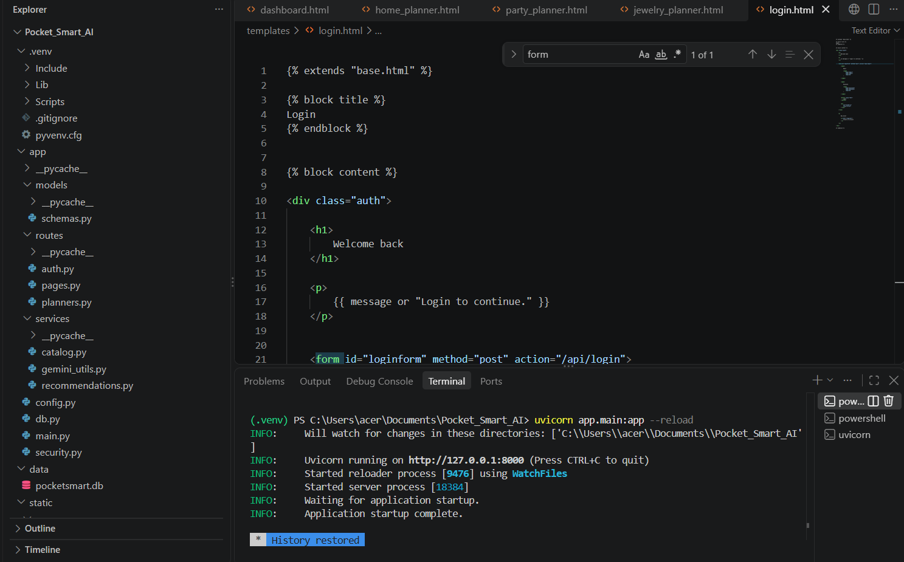

5.3 Project Folder Structure
The project files are organized into appropriate folders and modules.
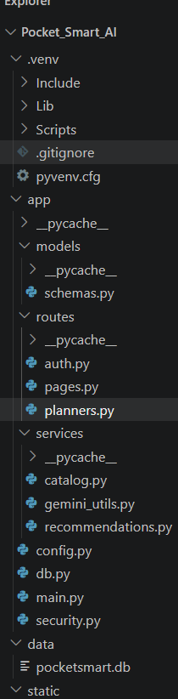
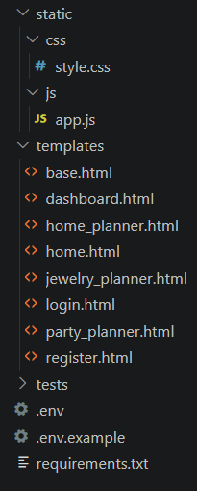

5.4 Backend Development
FastAPI is used as the backend framework. It handles application routes and processes requests received from the frontend.
The backend acts as the main processing layer between the user interface, database, and recommendation functionality.
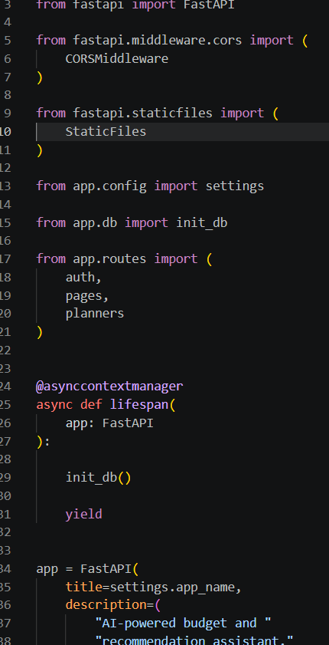

5.5 Database Implementation
SQLite is used as the application's database.
The database is initialized with the required tables for storing user information and recommendation-related data.
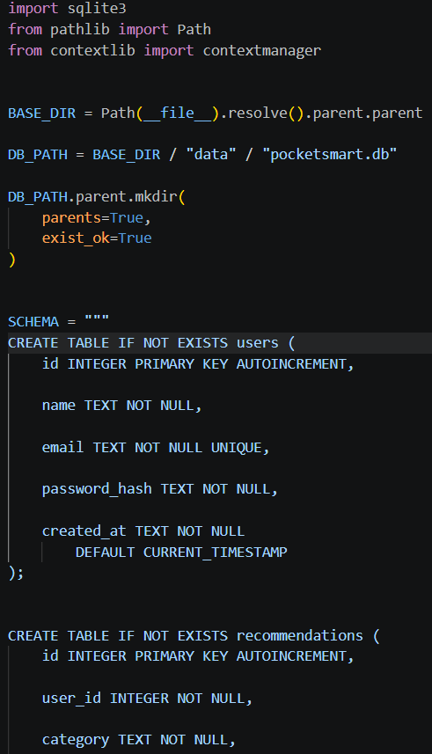
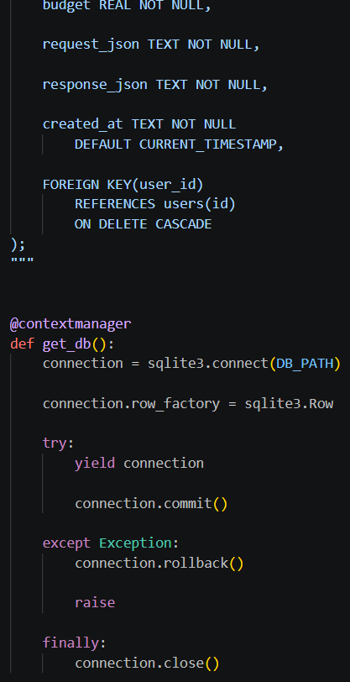
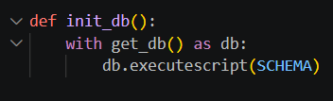

5.6 Authentication Module
The application includes user authentication functionality.
The authentication flow allows users to register and subsequently log in to access protected application functionality.
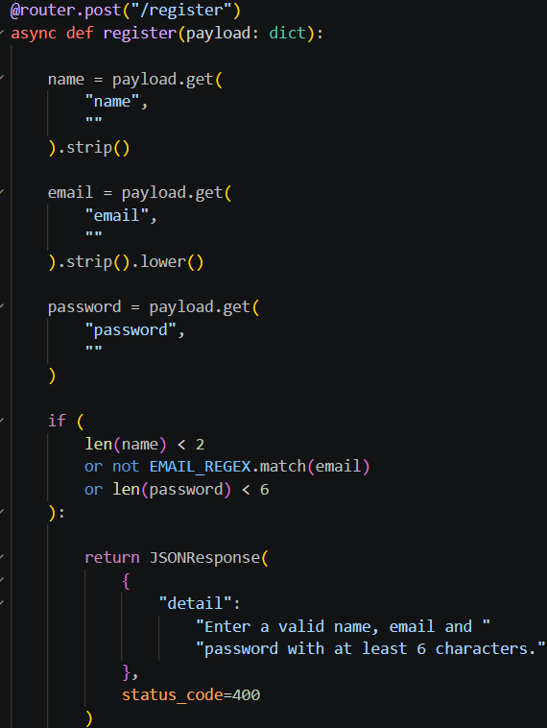
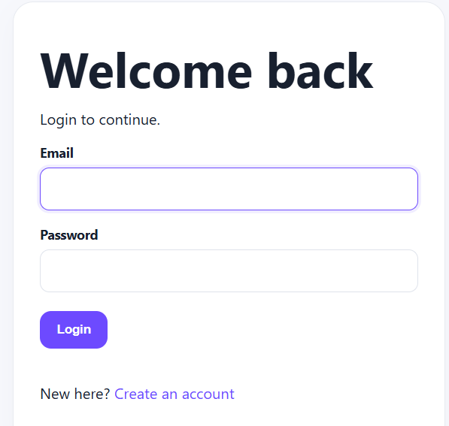

5.7 Dashboard Development
After authentication, the user can access the dashboard.
The dashboard provides access to the main application functionality and available recommendation features.
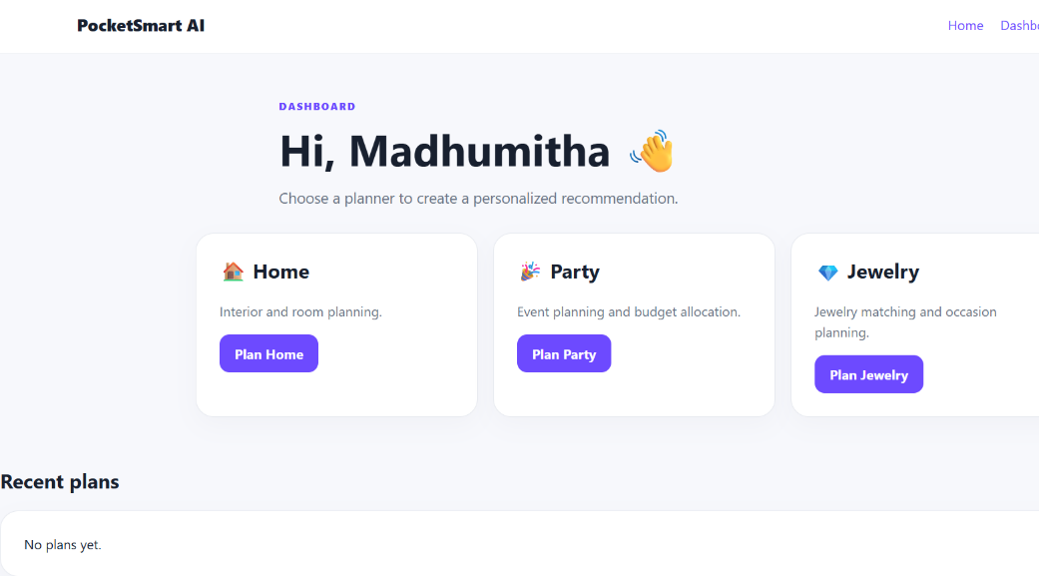

5.8 Budget and Requirement Input
The application collects the user's budget and required information through the appropriate interface.
The information is submitted to the backend for processing.
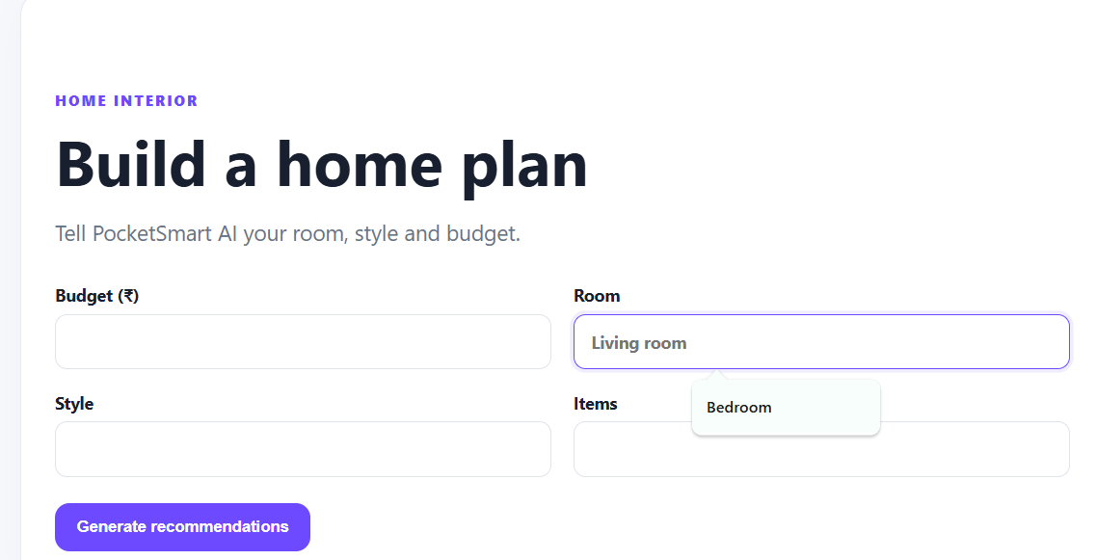

5.9 Recommendation Module
The recommendation module processes the user's submitted information and generates recommendations according to the implemented application logic.
The recommendation process considers the budget and other information supplied through the application.
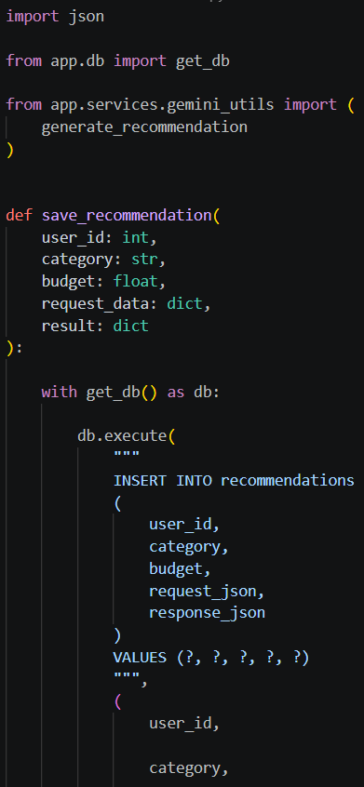
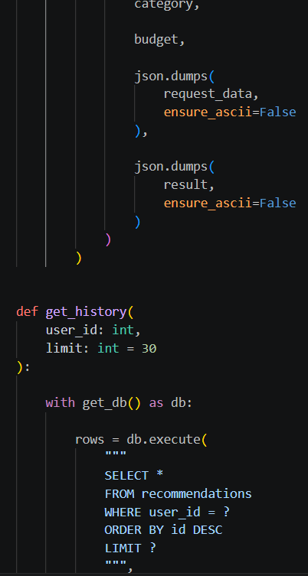
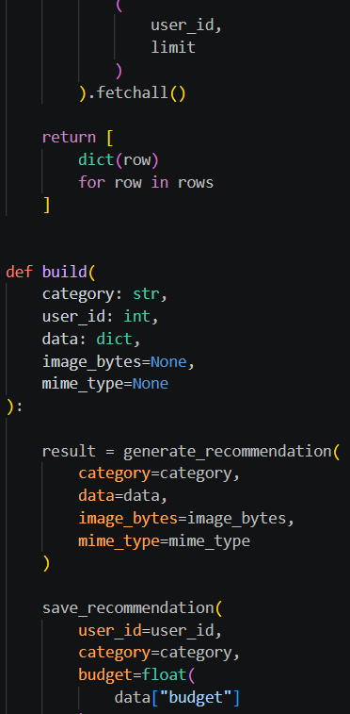
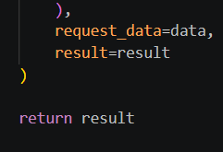

5.10 Recommendation Result
After processing the request, the application displays the generated recommendations to the user.
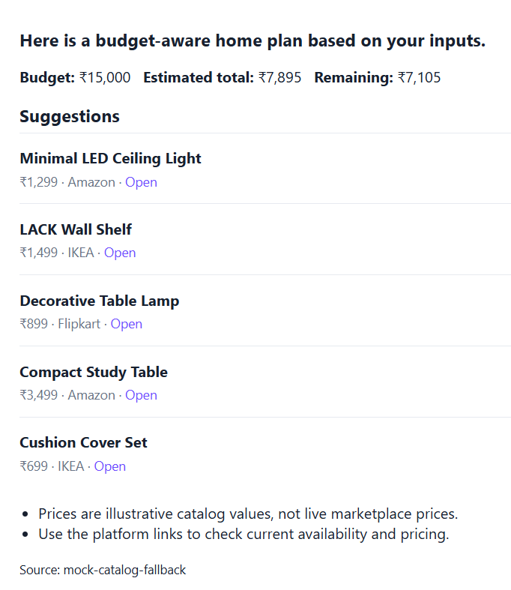

5.11 Recent Plans / History
The application maintains recommendation-related information so that previous plans can be accessed through the relevant history/recent plans functionality.


5.12 Application Execution
The FastAPI application is executed through the development terminal.
A successful execution displays the server startup information.
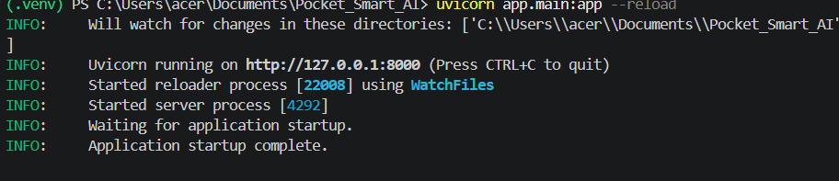

5.13 Development Summary

The development phase resulted in a working web application that combines user authentication, budget input, recommendation generation, database storage, and result presentation.

